To: INDIVIDUAL DOCTORS
From: Foundation for Chiropractic Progress
Re: September Awareness Campaign
Date: August 2017

2017 Public Relations Plan Strategies and Tactics

The following is a strategic communications plan to guide the INDIVIDUAL DOCTOR in the planning and implementation of its September 2017 Drug-Free Pain Management Awareness Month initiatives. The activities in September are designed to raise consumer awareness of safer, drug-free pain management options, such as chiropractic, before taking opioids.

INDIVIDUAL DOCTOR can achieve local and regional public relations objectives through the execution of a variety of tactics. The following is a description of those tactics, along with examples of how they may be applied to deliver key messages this September.

The following articulates each focus:

Detailed Tactical Recommendations

Tactics:

1) Review the Members-Only Marketing Toolkit:
http://f4cp.com/resources/marketingtoolkit/

2) Review the Consumer Website
http://drugfreepaincare.org

3) Review the Powerpoint for a community lecture:
http://f4cp.com/files/f4cp-pub/opioid_crisis_and_you.pptx

4) Review the September Calendar with your staff.

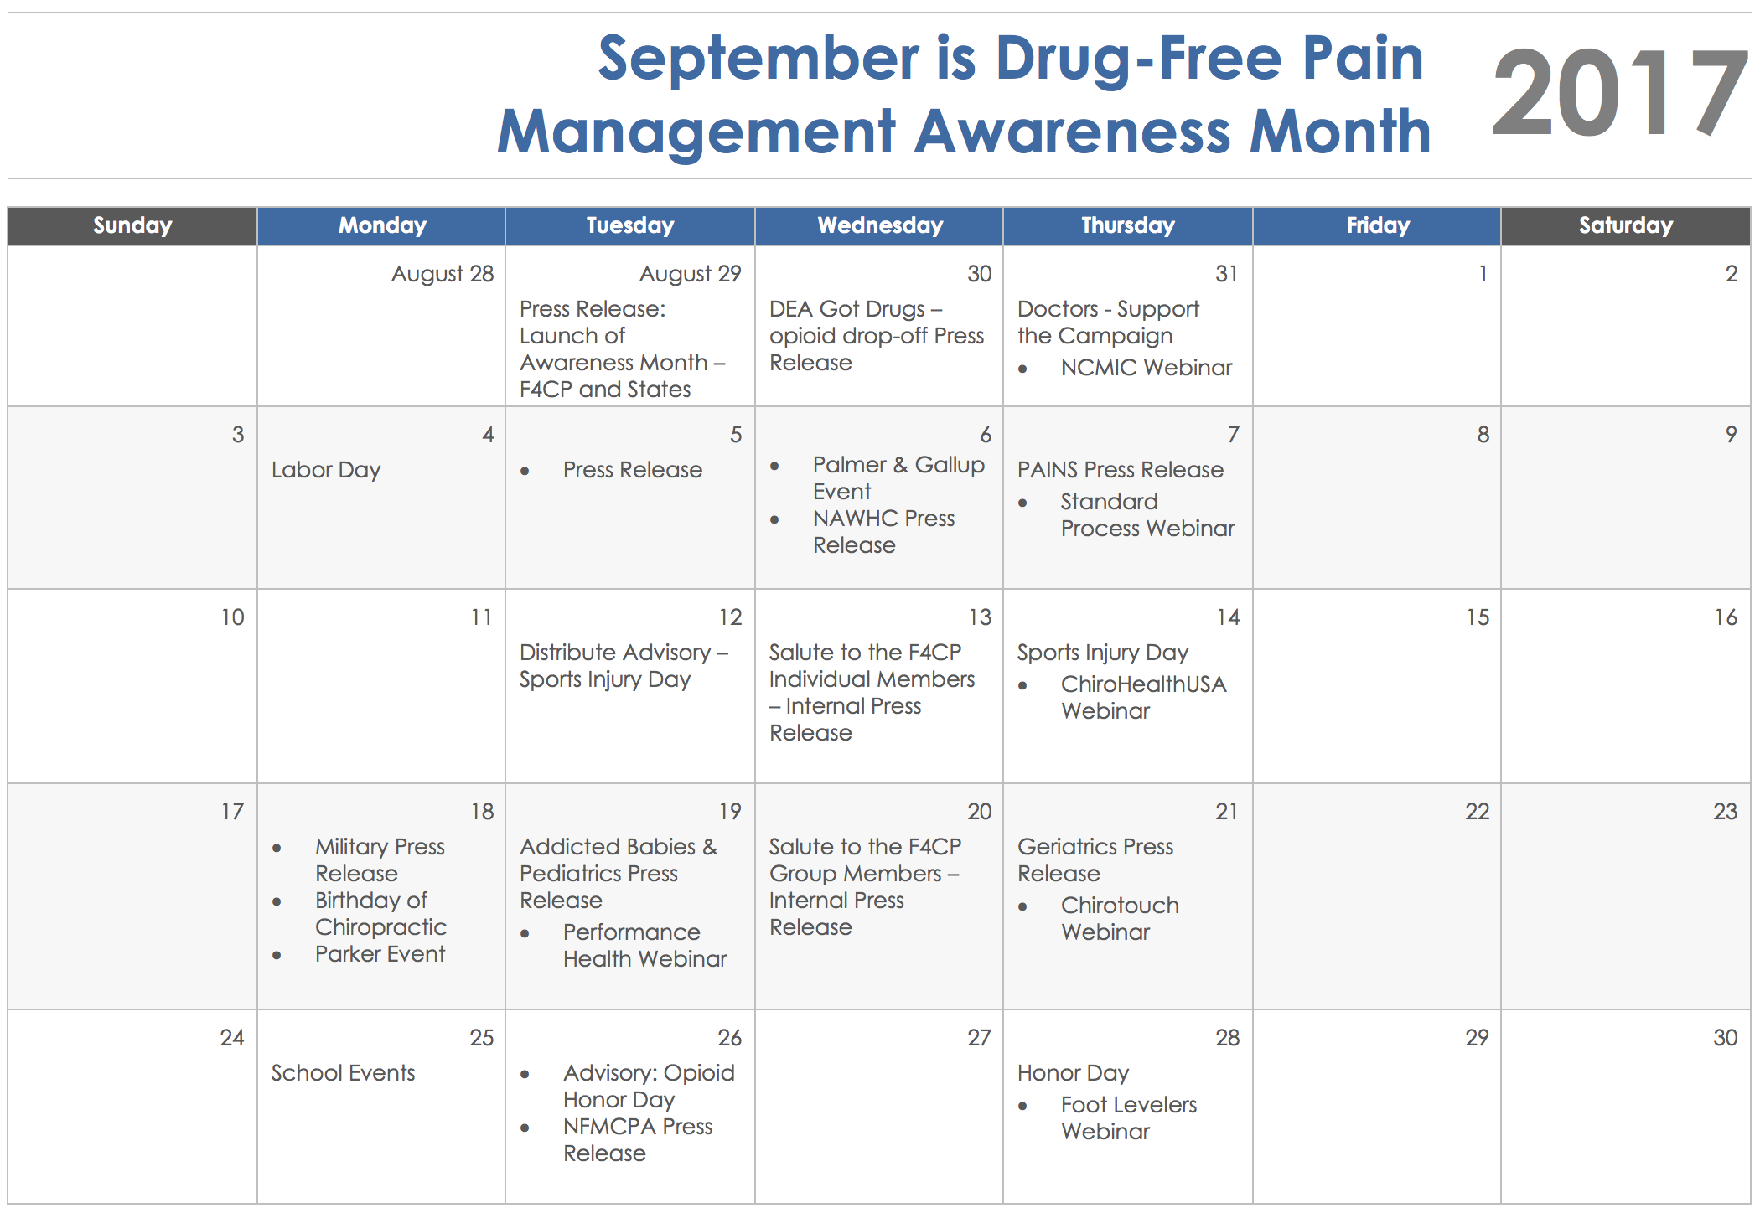
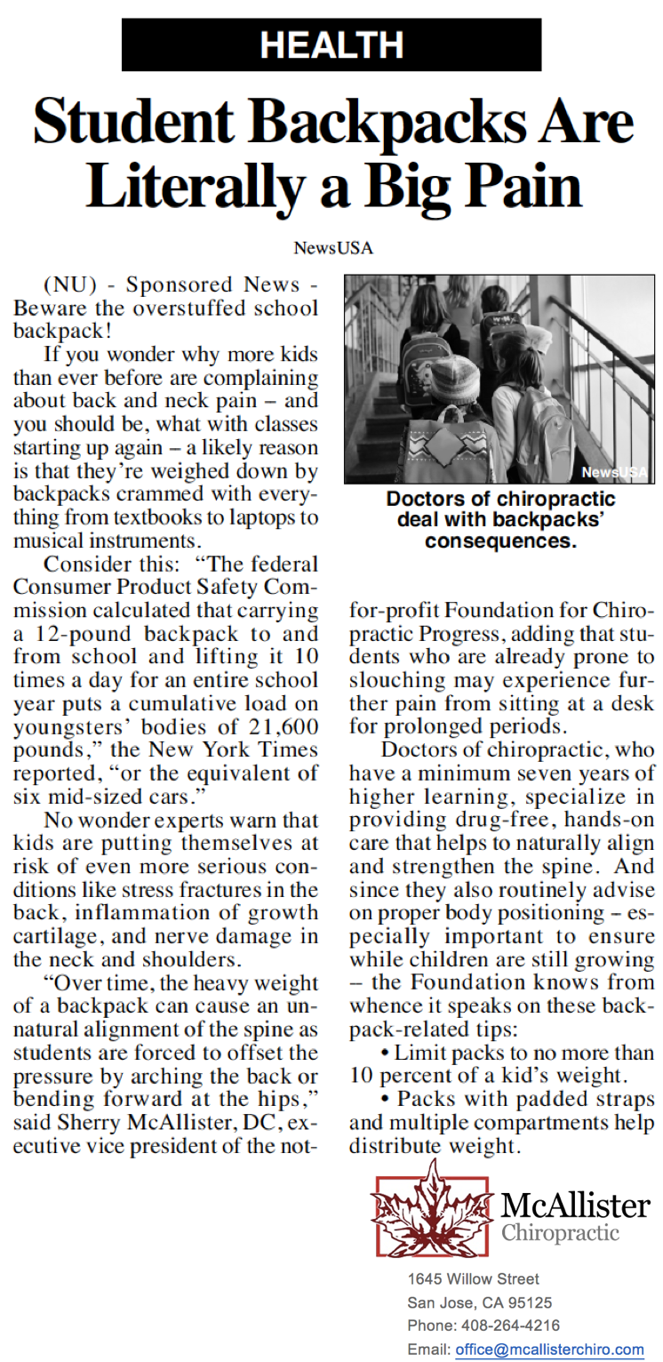
August

- Contact local newspapers (small and mid-size) offer advertorials electronically-customize with doctor’s names or association.

Contact Marketing Director, Alexis Lignos, alexis@f4cp.com if you need a media list generated.

Advertorials to customize and distribute:
- http://www.f4cp.com/files/f4cp-pub/Drug-Free-Pain-Management-Advertorial.pdf
- http://www.f4cp.com/files/f4cp-pub/addicted-babies-advertorial.pdf
- http://www.f4cp.com/files/f4cp-pub/amateur-athletes-advertorial.pdf

Customized advertorial example – justified right.

- Share the customized advertorial on social media.
- Post to your website and print out in-office.

- Contact local TV stations and personally provide a public service announcement (PSA) requesting a September airing. Start requests at the end of July.

Public Service Announcement to share: https://www.youtube.com/watch?v=60FWlRgw7Ic

- Contact local legislative body (Board of Supervisor or City Council) requesting a Proclamation for month of September. Customize the sample letter below and attach the resolution.

- Sample Letter: http://www.f4cp.com/files/resources/5.24.17-legislator-letter.pdf
- Resolution: http://www.f4cp.com/files/resources/5.24.17-resolution.pdf

Webinars

GAC Webinar
Listen to the Group Advisory Committee (GAC) webinar, “Success Lies in the Details: Walk-Through September Materials to Ensure Your State is Successful,” recording and review the slide deck for a better understanding of the September campaign activities.

- Webinar Recording: https://www.dropbox.com/s/379vmng9ju9alo8/2017-07-19%2012.00%20Success%20Lies%20in%20the%20Details_%20Walk-Through%20September%20Materials%20to%20Ensure%20Your%20State%20is%20Successful.mp4?dl=0
- Download the PowerPoint Slides: http://www.f4cp.com/member-services/marketing-materials/Files/Marketing%20Resources%20-%20GAC%20PowerPoint%20Presentations/7.19.17-GAC-Walk-Through.pptx

Upcoming Webinar Series
Register for the six-part webinar series presented by F4CP Corporate Sponsors:

- Thursday, August 31 – NCMIC: https://attendee.gotowebinar.com/register/1882760115174711298
- Thursday, September 7 – Standard Process: https://attendee.gotowebinar.com/register/5937846959342862338
- Thursday, September 14 – ChiroHealthUSA: https://attendee.gotowebinar.com/register/2646649117107025154
- Tuesday, September 19 – Performance Health: https://register.gotowebinar.com/register/5098490777814918658
- Thursday, September 21 – Chirotouch: https://attendee.gotowebinar.com/register/3552876496324668930
- Thursday, September 28 - Foot Levelers: https://attendee.gotowebinar.com/register/6921302935783890946

Special Events

Attend special events at the Florida Chiropractic Association (FCA) The National Meeting in August:

- Connect with us! Visit F4CP booth #1302.
- Attend F4CP Executive Vice President Dr. Sherry McAllister’s panel presentation and opioid abuse class:
  - FCA Schedule: https://thenationalchiro.com/the-schedule

Press Release

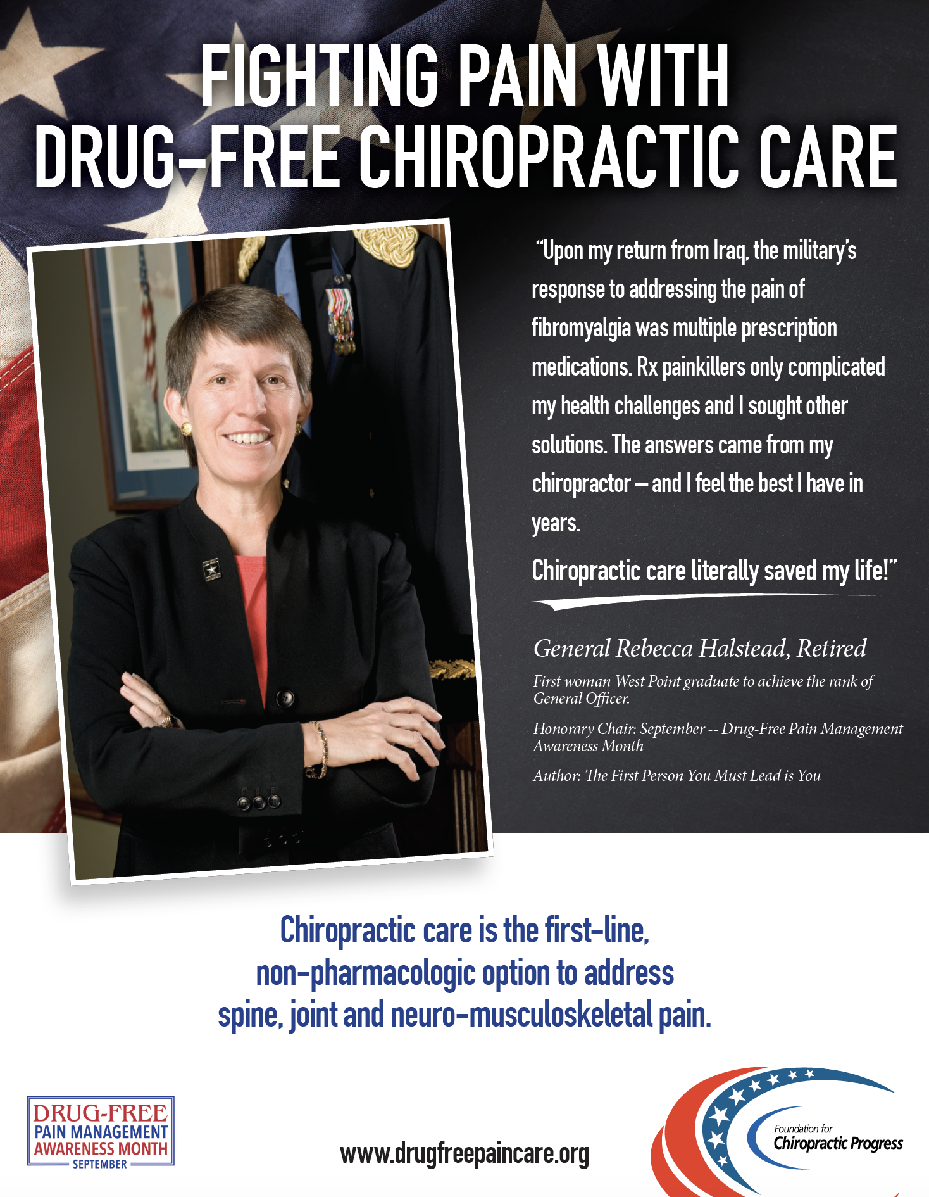
Distribute a customized press release to your local newspapers on August 29, 2017, announcing September as Drug-Free Pain Management Awareness Month.

Download and customize the press release below:
- Microsoft Word file: http://www.f4cp.com/files/resources/8.29.17SeptMonthDoctors.docx
- PDF file: http://www.f4cp.com/files/resources/8.29.17SeptMonthDoctors.pdf

Follow-Up with Editors

- Email local media the August 29th press release – do not send attachments. Paste the press release in the body of the email.
- Media list – need a targeted list of editors? Email Marketing Director, Alexis Lignos: alexis@f4cp.com.
- Follow-up with reporters by email 48-hours after release distribution. Include ‘FOLLOWING UP’ in the subject line.
- Do not call reporters.
- Post press release to practice website, newsletter and social media platforms. Print-out and place in the office waiting room.

September

Week One

Doctor’s Reception area:
- Print and post F4CP General Becky Halstead 18x24 poster in office: http://www.f4cp.com/member-services/marketing-materials/Files/F4CP%20Posters/Becky_Drug-Free_18x24_072617.pdf.
- Distribute 8.5 x 11” information sheet to each patient that visits during the month of September – print out and share copies of the General Becky Halstead handout: http://www.f4cp.com/member-services/marketing-materials/Files/F4CP%20Posters/Becky_Poster_8.5x11_073017.pdf.
- Print out and post advertorial in reception area (Rotate weekly): http://www.f4cp.com/files/f4cp-pub/Drug-Free-Pain-Management-Advertorial.pdf
- Social Media - Post the following text on social media on Tuesday, August 29:
  - Mark your calendar - September is Drug-Free Pain Management Awareness Month. To learn more, visit: drugfreepaincare.org. #StopOpioidAbuse
- Social Media - Post the following on social media on Friday, September 1:
  - Common painkillers raise risk of heart attack – consult your chiropractor for drug-free pain relief! www.f4cp.com/findadoctor #StopOpioidAbuse
- Social Media Accelerators™ - please check your inbox for emails from the Foundation including easy-to-share social media content for Facebook and Twitter. Subject line is: “Share F4CP Resources on YOUR Platforms”
- If doctor has patient lectures, schedule one on opioid abuse to the community. Here is a link to download the Consumer Awareness PowerPoint presentation: http://f4cp.com/files/f4cp-pub/opioid_crisis_and_you.pptx

Community Outreach:

Schedule presentation to local service club utilizing the F4CP video, Dr. Sean Drake Highlights Value of Chiropractic Care for Athletes: https://www.youtube.com/watch?v=60FWlRgw7Ic
- If there is a local health fair, secure a booth or table.

Mainstream Media:
- Placement of one or more advertorials should have already been completed.

Week Two (Same as week 1 with exception)
- Doctors Reception Room -- Print out and post advertorial in reception area (Rotate weekly): http://www.f4cp.com/files/f4cp-pub/addicted-babies-advertorial.pdf
- Distribute Kathryn Sundquist JA patient handout to patients that visit during the month of September: https://www.youtube.com/watch?v=3qcDHVfMkK8&t=4s
- Community Outreach
- Social Media – Post the following on social media on Wednesday, September 6:
  - MILLENIALS: Opioid addiction is real. Before you start taking painkillers, consult a chiropractor for care: www.f4cp.com/findadoctor.
- Social Media Accelerators™ - please check your inbox for emails from the Foundation including easy-to-share social media content for Facebook and Twitter. Subject line is: “Share F4CP Resources on YOUR Platforms”
- Mainstream Media: Consider placing an ad in the local newspaper with either local or state proclamation.

Week Three
- Doctors Reception Room: Schedule day when doctor visits are donated to campaign. Consider seeking contribution from patients. Here is a link to the in-office flyer: http://www.f4cp.com/member-services/marketing-materials/Files/Drug%20Free%20Pain%20Care/I_support.pdf.
- Distribute trifold brochure about opioids to each patient that visits during the month of September: http://www.f4cp.com/files/resources/F4CP_Opioid_Trifold.pdf
- Community Outreach
- Social Media – Post the following on social media on Tuesday, September 12:
  - Chiropractic care is a safer, drug-free and non-invasive pain management option. #ThinkChiropractic #StopOpioidAbuse
- Social Media Accelerators™ - please check your inbox for emails from the Foundation including easy-to-share social media content for Facebook and Twitter. Subject line is: “Share F4CP Resources on YOUR Platforms”
- Mainstream Media

Week Four
- Doctor’s Reception Room – Print out and post advertorial in reception area (Rotate weekly): http://www.f4cp.com/files/f4cp-pub/amateur-athletes-advertorial.pdf
- Distribute handout about opioids to each patient that visits during the month of September: http://ftp.f4cp.com/member-services/marketing-materials/Files/Brochures/F4CP_patient_ed_sheet_r1.pdf
- Community Outreach
- Mainstream Media
- Social Media – Post the following on social media on Tuesday, September 19:
  - From 1999 to 2014, more than 165,000 people died in the U.S. from prescription opioid overdoses -- 3 times the U.S. military deaths during the 20 years of the Vietnam War. Chiropractic offers a safer strategy for pain. #ThinkChiropractic #StopOpioidAbuse
- Social Media Accelerators™ - please check your inbox for emails from the Foundation including easy-to-share social media content for Facebook and Twitter. Subject line is: “Share F4CP Resources on YOUR Platforms”

